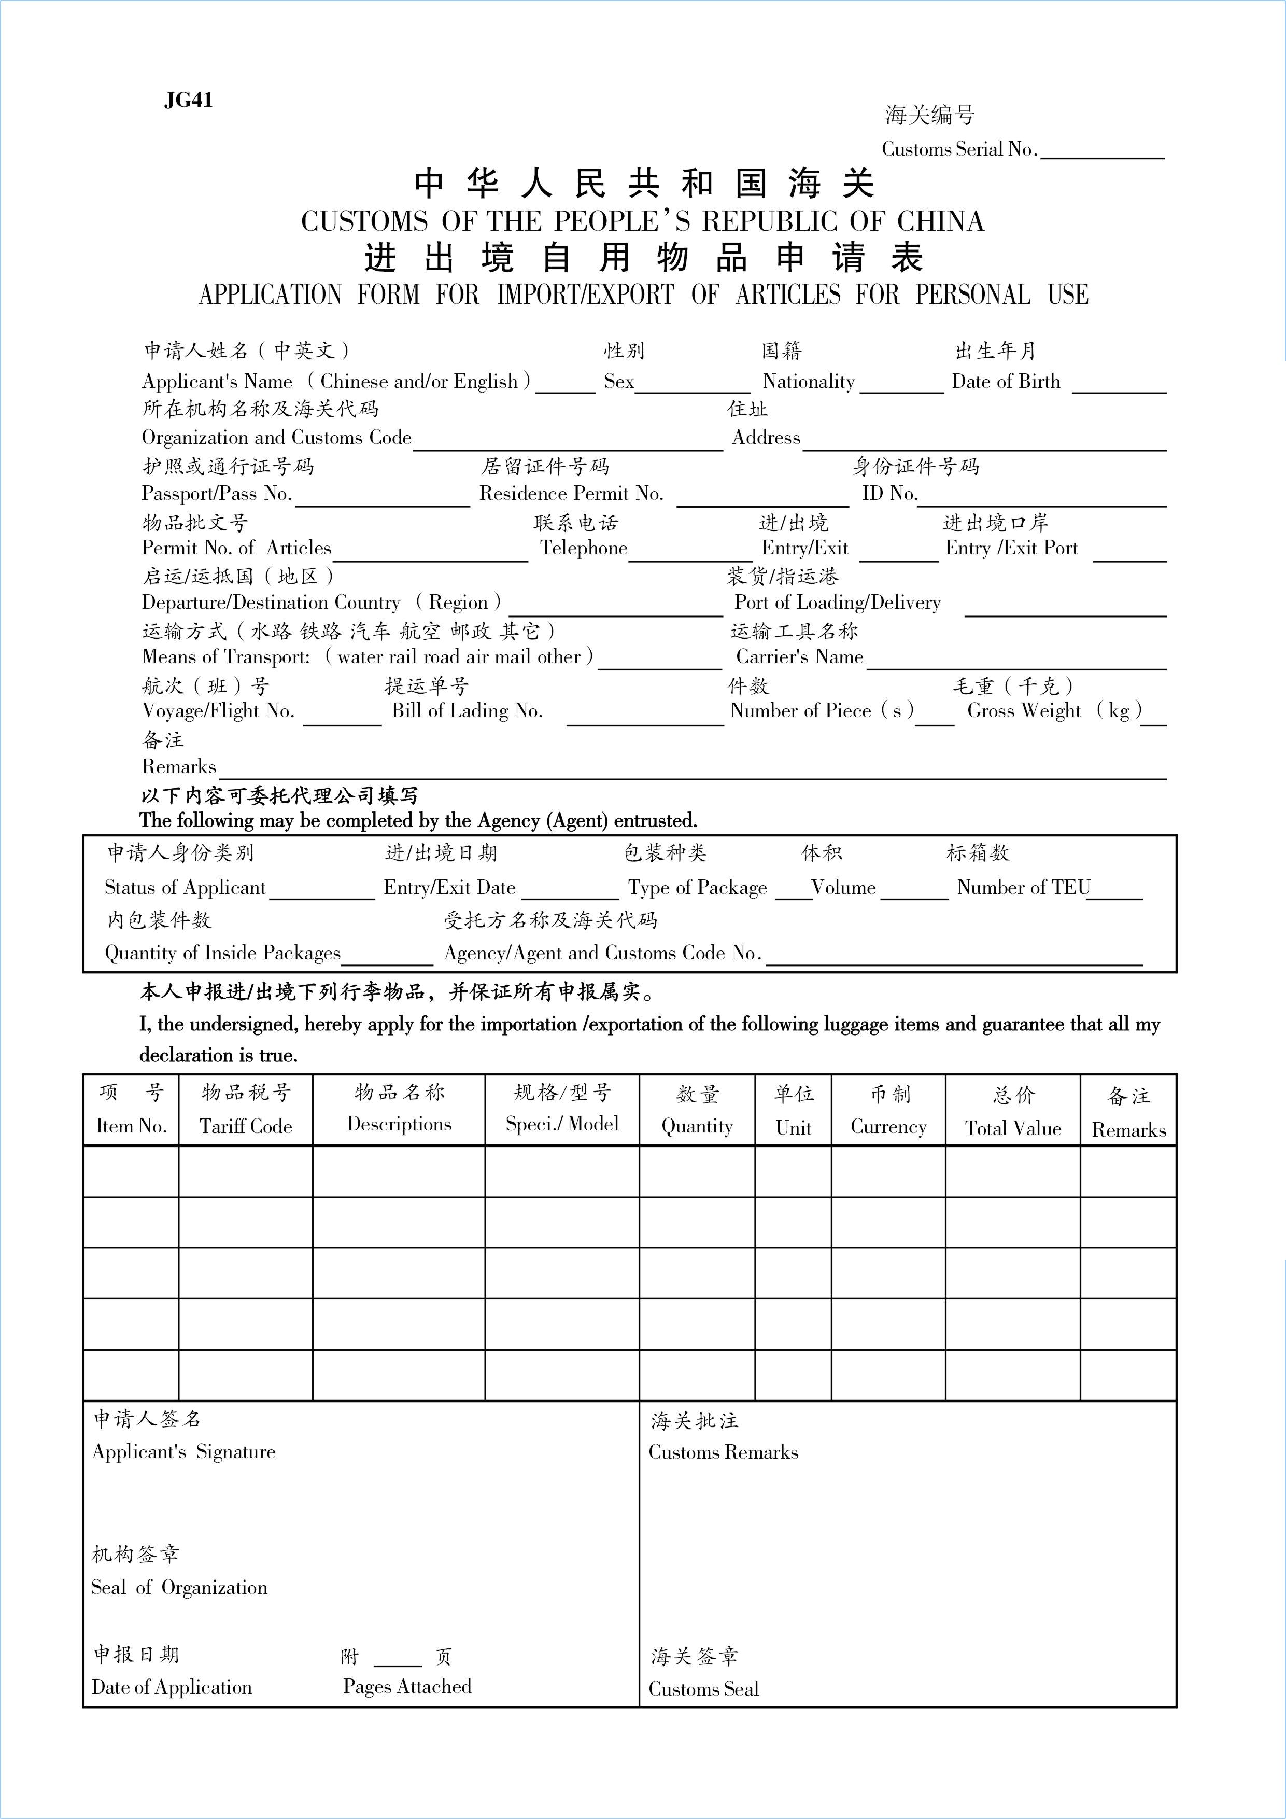
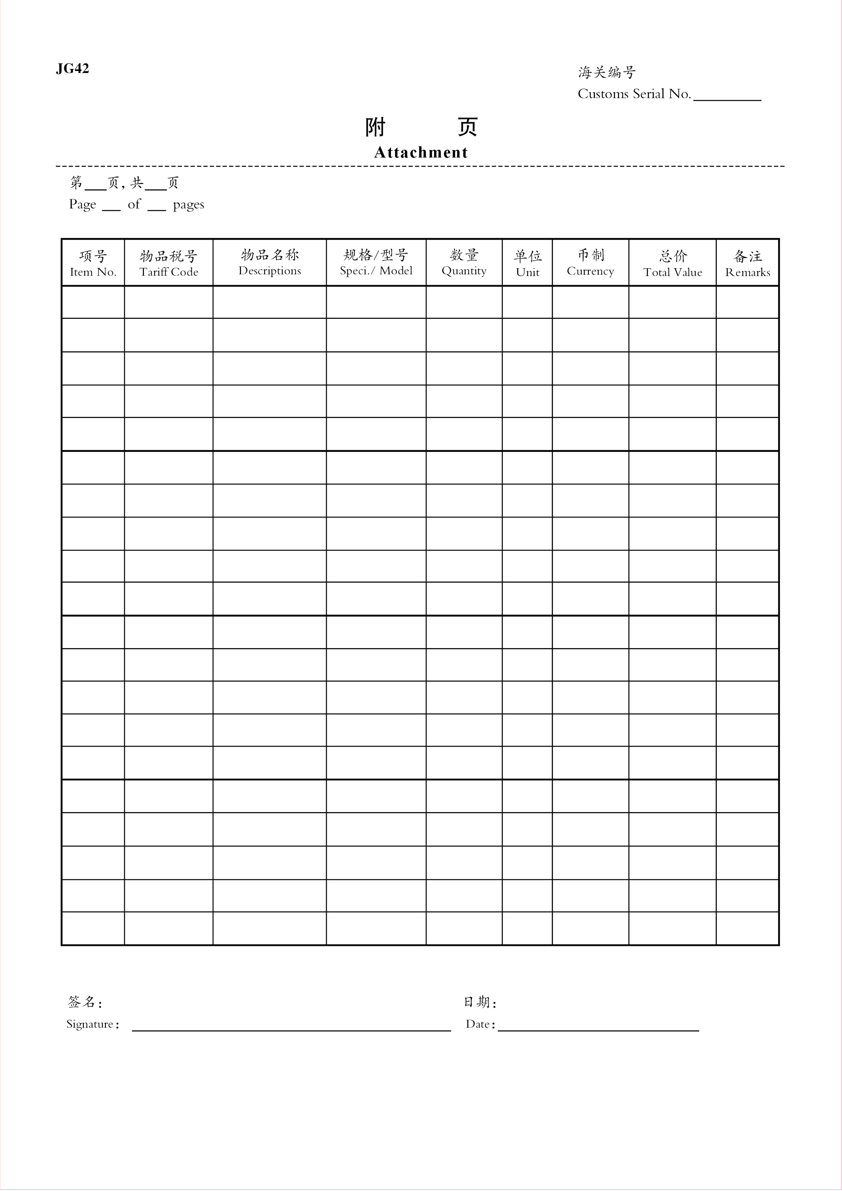

JG41填表说明：

1.申请人姓名（中英文）：按进出境有效证件填写。
2.性别：按进出境有效证件填写。
3.国籍：按进出境有效证件填写（中国驻外使领馆馆员不填写国籍，填写原驻在国及驻在城市）。
4.出生年月：按进出境有效证件填写。
5.所在机构名称及海关代码：境内所在机构的规范中文全称及海关十位数代码。
6.住址：境内住址。
7.护照或通行证号码：进出境有效证件的号码。
8.居留证件号码：有效期一年期以上居留许可证号码或华侨、港澳同胞暂住证号码或台湾居民居留签注号码等。
9.身份证件号码：外国（地区）企业常驻代表机构工作证、外国人就业证、外国专家证等证件的号码（中国驻外使领馆馆员填写驻外使领馆人员身份证明号码）。
10.物品批文号：填写相关部门批准进出境禁限物品的批准文号，无禁限物品的免填。
11.联系电话：境内联系电话。
以下内容按提货单填写
12.进/出境：进境、出境、其他（写明原因，如报废等）。
13.进出境口岸：物品实际进出我国关境口岸海关的名称。
14.启运/运抵国（地区）：启运国（地区）指进口货物直接运抵我国的起始发出的国家（地区）；运抵国（地区）指出口货物离开我国关境直接运抵的国家。无实际进出境的，本栏目填报中国。请按海关规定的《国别（地区）代码表》选择填报相应的起运/运抵国（地区）的中文名称。
15.装货/指运港：装货港指进口物品在运抵我国关境前的最后一个境外装运港；指运港指出口物品运往境外的最终目的港。无实际进出境的，本栏目填报“中国境内”。请按海关规定的《港口航线代码表》选择填报相应的港口中文名称。
16.运输方式：水路运输；铁路运输；汽车运输；航空运输；邮政运输； 其它运输（须注明具体方式）。
注：非邮政方式进出口的快递物品，按实际运输方式填报，如航空运输；进出境旅客随身携带的自用物品，应填报其它运输。
17.运输工具名称：水路运输填报船舶编号或船舶英文名称；铁路运输填报车厢编号或交接单号；汽车运输填报该跨境运输车辆的国内行驶车牌号；航空运输免予填报；邮政运输填报邮政包裹单号；其它运输填报具体运输方式名称。
18.航次(班)号：水路运输填报船舶的航次号；铁路运输填报进出境日期；汽车运输填报该跨境运输车辆的进出境日期（8位）；航空运输免予填报；邮政运输填报进出境日期；其他各类运输方式免予填报。
19.提运单号：水路运输填报进出口提运单号，如有分提运单的，填报进出口提运单号+“*”+分提运单号；铁路运输填报运单号；汽车运输免予填报；航空运输填报总运单号+“_”(下划线)+分运单号,无分运单的填报总运单号；邮政运输填报邮运包裹单号；其他各类运输方式免予填报。
20.件数：按提货单或场站收据填写。
21.毛重(千克)：按提货单或场站收据填写。计量单位为千克，不足1千克的填报为“1”。
22.备注：需向海关说明的其它情况。（中国驻外使领馆馆员在此栏填报离任回国证明书号、境外购车日期、发票号码）
23.申请人身份类别：选择以下一种身份填写。
常驻人员；非居民长期旅客；来华定居旅客；中国驻外使领馆馆员；其他人员。
24.进/出境日期：运输工具进/出境的日期，无实际进出境的填申报日期。
25.包装种类：选择以下一种内包装填报。木箱；纸箱；桶装；散装；托盘；包； 其它。
26.体积：按提货单或场站收据填写，计量单位为立方米。
27.标箱数：标准集装箱数量（散货填报为“0”，1个20呎集装箱填报为“1”，1个40呎集装箱填报为“2”，以此类推）。
28.内包装件数：内包装箱（如纸板箱）件数。
29.受托方名称及海关代码（身份证件号码）：委托代理公司申请的，填报代理公司名称及海关代码；委托他人申请的，填报受托人姓名和身份证件号码。
以下内容按装箱清单、发票填写：
30.项号：物品序列号。
31.物品税号：按《入境旅客行李物品和个人邮递物品进口税税则归类表》归类填写。
32.物品名称：物品规范的中文商品名称。汽车申报为：车辆牌名（如捷达、佳美等）+排气量（以“CC”为单位）+车型（如越野车、小轿车等）+车驾号，旧车应在车辆牌名前加“旧”字，新车不加。
33.规格/型号：如普通电视机应申报荧幕尺寸，冰箱应申报容积数，汽车申报型号，如E320、750I等。
34.数量：按申请物品的实际数量填写。如电脑主机1台、CD片20片、家具5件。
35.单位：按法定计量单位填写。
36.币制：按发票币制填写。
37.总价：该项物品的总价。
38.申请人签名：由申请人本人按进出境有效证件签字样式签名。
39.机构签章:申请人所在机构公章。
40.申请日期：向海关呈交申请表的日期。
41.附页数：附页总页数（无附页的填“0”）。

JG41 Instructions:

1.Applicant’s Name: (Chinese and/or English): The name as indicated on the valid certificate for entering or leaving China.
2.Sex: The sex as indicated on the valid certificate for entering or leaving China.
3.Nationality: The nationality as indicated on the valid certificate for entering or leaving China.
4.Date of Birth: The date of birth as indicated on the valid certificate for entering or leaving China.
5.Organization and Customs Code: Standard full Chinese name of the organization in China and its 10-digit Customs code.
6.Address: The address in China.
7. Passport/Pass No.: The number of the valid certificate for entering or leaving China.
8.Residence Permit No.: The number of the Residence Permit valid for over one year or the number of the Temporary Residence Permit for Overseas Chinese or Compatriots from Hong Kong and Macau or the registration number of residence for Taiwan residents.
9.ID No.: The number of the ID of Resident Representative Office of Foreign (Regional) Enterprises, Employment Permit for Foreigners and Foreign Expert Certificate, etc..
10.Permit No. of Article: Indicate the serial number of permit issued by competent authorities approving the importation/exportation of restricted and prohibited article(s). Leave this item blank if no such articles are involved.
11.Telephone: Telephone number in China.
Complete the following information with reference to the Bill of Lading.
12.Entry/Exit： Indicate entry, exit and other. If “other” is selected, reasons such as “scrapped” shall be stated.
13.Entry/Exit Port: The name of the Customs port within China’s Customs territory where the actual importation or exportation of relevant articles is effected
14.Departure/Destination Country/Region: Departure country/region refers to the original starting country/region from which the import goods are directly consigned to China’s Customs Territory. Destination country/region refers to the country/region to which the export goods are directly consigned from China’s Customs territory. In case there is no actual importation or exportation, fill in “China” in this item. Give the corresponding name in Chinese for the departure/destination country/region in conformity with 《Country/Region Code》 prescribed by China Customs.
15.Port of Loading/Delivery: The port of loading refers to the last overseas port where the import goods are loaded before their arrival in China’s Customs Territory. The port of delivery refers to the final foreign destination port to which the export goods are consigned. In case there is no actual importation or exportation, fill in “within China’s Customs territory” in this item. Give the corresponding name in Chinese for the port in conformity with “Port and Route Code” prescribed by China Customs.
16.Means of Transport: Transport via water; rail; road; air mail; or other (to be specified).
Note: For those inward or outward express parcels by non-mail, give the actual means of transport such as “air”. As for articles for official use carried by inward or outward passengers, indicate “other”.
17.Carrie’s name: For water transport, give the number or English name of the vessel. For rail transport, give the carriage number or the transit receipt number. For road transport, give the license plate number of the cross-border vehicle running in China. For air transport, no record is needed. For mail consignment, give the number of the mail parcel form. And, for “other”, give the specific means of transport.
18.Voyage/Flight No.: For water transport, give the voyage number of the vessel. For rail transport, give the date of entry or exit of the territory. For road transport, give the numeric eight-digit date of entry or exit of the cross-border vehicle. For air transport, no record is needed. For mail consignment, give the date of entry or exit of the territory. No entry of this item is needed for various other means of transport.
19.B/L No.: For water transport, give the B/L No.. If there is a house B/L, give the import or export B/L No. plus “*” plus house B/L No.. For rail transport, give the waybill No.. For road transport, no entry is needed. For air transport, give “MAWB No. plus “__”(underline) plus HAWB No.”. Give MAWB No. if HAWB is not available. For mail consignment, give the number of the mail parcel form. No entry of this item is needed for various other means of transport.
20.Number of pieces: Give the number of pieces as shown in the B/L or Dock/Station Receipt.
21.Gross Weight (kg): Give the number of pieces as shown in the B/L or Dock/Station Receipt. The unit of measurement is kilogram. Indicate “1” for the weight less than one kilogram.
22.Remarks: Other explanations necessary for the Customs.
23.Status of Applicant: Select one of the following:
Resident personnel; long-term non-resident; permanent settler to China; member of Chinese diplomatic missions and others
24.Date of Entry/Exit: Give the date of entry or exit of the territory of the carrier. In case there is no actual entry or exit, give the date of declaration.
25.Type of Package: Indicate one of the following packages: wooden case, carton, barrel, bulk, pallet, bag or other.
26.Volume: Give the number of pieces as shown in the B/L or Dock Receipt. The unit of measurement is cubic metre.
27.Number of TEU: The number of standard containers (“0” for bulk cargo; “1” for one twenty-foot container and “2” for one forty-foot container, and so on.)
28.Number of Inside Package: The number of inside packing cases such as cartons.
29.Name of the Party Entrusted and Customs Code (ID No.): The name and Customs code of the agency entrusted to make the declaration or the name and ID No. of the person entrusted to make the declaration.
Complete the following information with reference to the packing list and invoice.
30.Item No.: The Serial number of the article.
31. Tariff Code: Complete this item with the classification according to the 《Classification and Nomenclature of Import Customs Tariff on Inward Passenger’s Luggage and Postal Items for Personal Use》 .
32.Descriptions: The standard Chinese commercial name of the article. Automobiles are required to be declared as “brand (e.g. Jetta, Camry etc.) + exhaust capacity (measured by “cc”) + type (e.g. cross country vehicle, sedan car, etc.) + VIN. As for used automobiles, indicate “used” before the brand whereas for new ones, no indication is needed.
33.Specifications/Model: For the common TV set, the screen size shall be declared, for the refrigerator, its capacity measured by litre, and for the automobile, its model such as “E320” or “750I” etc..
34.Quantity: Declare the actual quantity of the article(s) being applied for. For example: “1 set” of computer mainframe, “20 discs” of CDs, “5 pieces” of furniture, etc..
35.Unit: Give the quantity of unit in accordance with the official measuring system.
36.Currency: Complete the item in conformity with the currency applied in the invoice.
37.Total Value: The total value of the article.
38.Applicant’s Signature: Signed by the applicant in conformity with the signature as shown on the valid certificate for entering or leaving the territory.
39.The official seal of the applicant’s organization.
40.Date of Application: The date of submission of this form to the Customs.
41.Page(s) Attached: The total pages of the attachment. If there is no attachment, indicate “0”.

